**Automatic Image Caption Generation**

# Created on April 05 2018

Members

Sayali Pisal

Sneha Patil

Chunchen Lin

# Table of Contents

1. Project Flow Diagram generated from mockflow.com
2. Basic Idea
3. Challenges
4. Future changes Additional Ideas

**Project Flow**

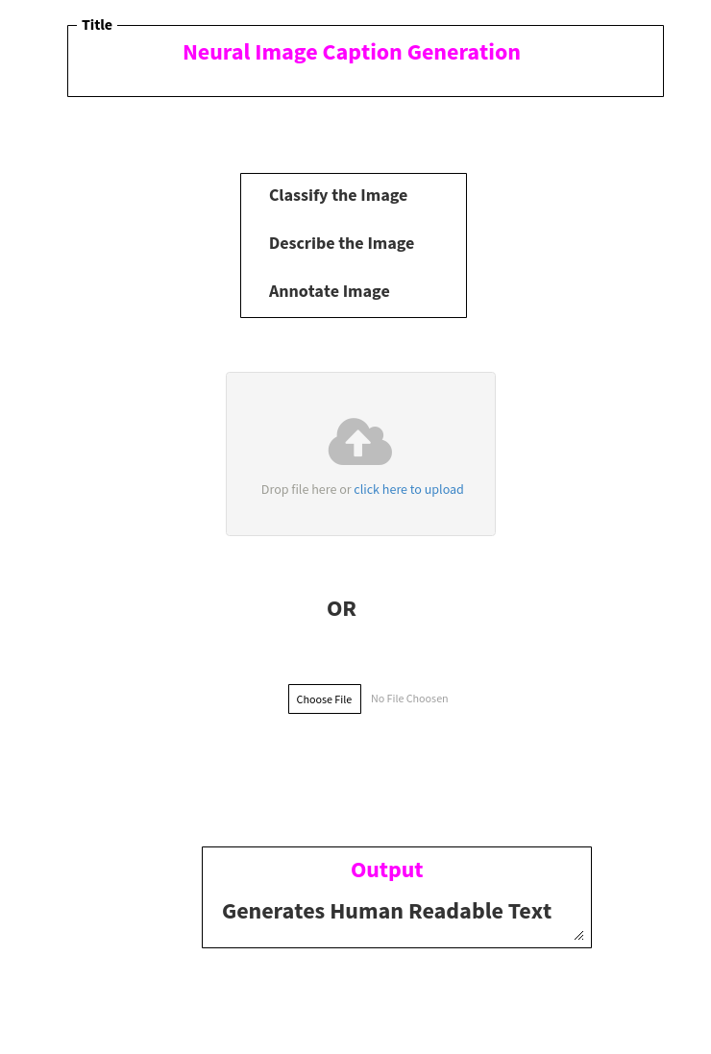

**Basic Idea**

Caption generation is way of generating caption or Textual description from a given photograph. This is a challenging Artificial intelligence problem which requires natural language processing and some deep learning methods.

Steps.

1. Identify the Data set to train the model. Prepare photo and text data
2. Design the model and train deep learning algorithm
3. Evaluate the model for caption generation

**Challenges**

Preparing the text data requires multiple photos and description of the photo. Each photo should have a unique identifier. Define each function to follow the steps in the algorithm. The next big challenge is to clean the description text. This step is called data cleaning. The description should be lower case letters with not punctuation marks and should not involve any numbers as well.

Defining the model

Loading the model

Training the model

Applications or Future changes.

1. Targeted Advertisement

Companies can find what the customers most likely interested by using this app to analyze image data of related customers to find how often the related product appears in the image with the customer in. Therefore, they can send related advertisement to that customer.

1. Forensic analysis

Police can use this app to analyze image data, e.g. the surveillance camera footages, to find if the suspect appears in the crime scene. Or police can use it to analyze images to find what they are interested.

1. Military application

Military can use this app to analyze remote sensing data collected by spy satellite to find if an object they are interested in the area, such as North Korea missiles.

1. Any companies or organizations wants to analyze image data to statistically mining image data to get what they needs, image description would be a handy tool.